Guide to Music at Barham
Music is part of the culture of our school. Listening to music and singing are everyday activities and we have countless opportunities to play and perform throughout the year; these include our Christmas Nativity, Talent Show, Spring Music Evening, Inter-House Music Competition, Summer Production, and many more!
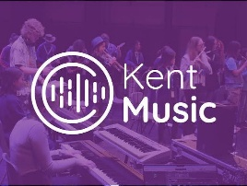
Kent Music
We are very lucky to have such a supportive local music network. Alan Gifford is our local network manager who often comes to our school music events as a guest judge and keeps us in regular touch with all the fabulous events happening locally, including a string orchestra at newly-established Canterbury Music Centre.
Learning a Musical Instrument at Barham School
Music Plus
The Music Plus Programme enables us to provide 20 weeks of whole class tuition to all children in our Year 4 class. They are lucky enough to be taught the basics on the violin and then to have a chance to also play the cello. We teach recorders throughout the year to our Year 3 class, enabling them to learn music-notation reading and to perform in a group.
We have fabulous music teachers at Barham. and recommend children will benefit most from starting individual lessons between the ages of 7 and 10. Individual and small-group lessons of different lengths are available. Please contact the school office if you would like information about lessons with these teachers:
Independent Teachers
Richard Ansell is an amazing piano teacher who teaches both in school and privately.
Becca Green teaches drumming in our purpose-built drum studio. We look forward to the drum concerts, where her pupils perform so confidently.
Ruben Zilberstein is a professional musician who we are really lucky to have at Barham teaching violin.
We do not currently have a brass or woodwind teacher, so please do let us know if you know if you would like this, or can help fill this gap.
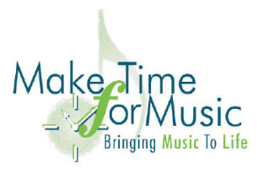
Make Time for Music
Make Time for Music s a charity which provides a number of instruments for private lessons. Here is the link to their website for information about individual or group lessons. !! Contact Make Time For Music in Kent
Here are their current teachers:
Tim Parker teaches our whole-class violin and cello lessons (see above).
Colin is a super guitar teacher who we have enjoyed working with for many years.
Alice has been at Barham a while now and is popular with her piano pupils. She is currently on maternity leave, so we look forward to meeting her replacement and hopefully welcoming her back in due time.

